**Department of IT and Computer Science**

**Pak-Austria Fachhochschule: Institute of Applied Sciences and Technology, Haripur, Pakistan**

**COMP-201L Data Structures and Algorithms Lab**

**Final Project Proposal**

**Fall 2021**

**Team Members**

**Muhammad Suleman**

**B20F0012CS035**

**Yaseen Ejaz Ahmed**

**B20F0283CS014**

The Network Emulator

A network is a set of connected electronic devices such as routers, and computers etc., where each device has a unique identification address (e.g., IP address). A message is sent from one device to another using the destination (recipient) address. Clearly, the message will have to follow a route (i.e., path of routers) in the network to get delivered to the desired destination device. On the path, each router checks the destination address of the message and forward it accordingly to the next router or the destination computer. For this purpose, a router typically maintains a table (named as routing table) containing the information about where to forward a message with certain destination address.

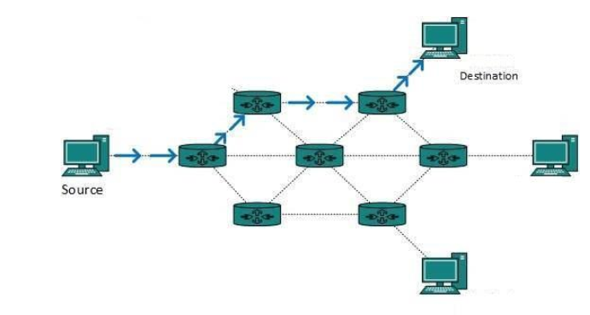

**Components:**

The following components shall be used for the network:

* Modem (Root)
* Router (Nodes)
* Computers (Leaves)

**Working:**

A network consists of computers communicating with one another. Messages are sent to specific computers or the whole network.

User shall enter:

* Source
* Destination
* Message
* Priority

**Data Structures to use:**

* Linked Lists
* Priority queues
* Trees for entire network

**Example of a network:**

